**Name-Tasmiya Fathima**

**USN-1BM19CS172**

**PROGRAM 1-( INSURANCE DATABASE)**

Consider the Insurance database given below. The primary keys are underlined and the data types are specified.

PERSON (driver-id #: String, name: String, address: String)

CAR (Regno: String, model: String, year: int)

ACCIDENT (report-number: int, date: date, location: String)

OWNS (driver-id #: String, Regno: String)

PARTICIPATED (driver-id: String, Regno: String, report-number: int, damage-amount: int)

**i. Create the above tables by properly specifying the primary keys and the foreign keys**

create database Insurance;

use Insurance;

create table Lab1.person (driver_id varchar(10),

name varchar(20),

address varchar(30),

primary key(driver_id));

desc person;

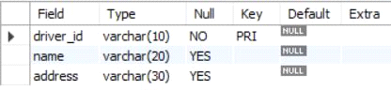

create table car(reg_num varchar(10),model

varchar(10),year int,primary key(reg_num));

desc car;

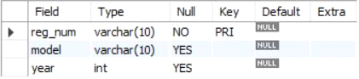

create table accident(report_num int,accident_date

date,location varchar(20),primary key(report_num));

desc accident;

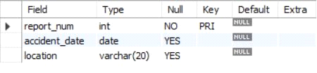

create table owns(driver_id varchar(10),reg_num

varchar(10),primary key(driver_id,reg_num),foreign key(driver_id) references person(driver_id),

foreign key(reg_num) references car(reg_num));

desc owns;

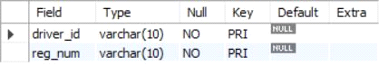

create table participated(driver_id

varchar(10), reg_num varchar(10),report_num int, damage_amount int,

primary key(driver_id,reg_num,report_num),

foreign key(driver_id) references person(driver_id),

foreign key(reg_num) references car(reg_num),

foreign key(report_num) references accident(report_num));

desc participated;

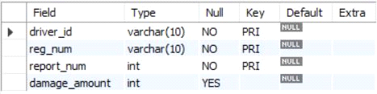

**ii. Enter at least five tuples for each relation**

insert into person values('A01','Richard','Srinivas Nagar');

insert into person values('A02','Pradeep','Rajajinagar');

insert into person values('A03','Smith','Ashoknagar');

insert into person values('A04','Venu','N.R.Colony');

insert into person values('A05','John','Hanumanth Nagar');

select * from person;

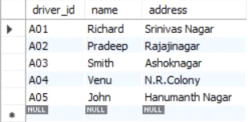

insert into car values('KA052250','Indica', 1990);

insert into car values('KA031181','Lancer', 1957);

insert into car values('KA095477','Toyota',1998);

insert into car values('KA053408','Honda',2008);

insert into car values('KA041702','Audi',2005);

select * from car;

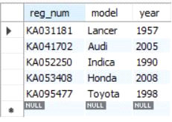

insert into accident values(11,'2003-01-01','Mysore Road');

insert into accident values(12,'2004-02-02','Southend Circle');

insert into accident values(13,'2003-01-21','Bulltemple Road');

insert into accident values(14,'2008-02-17','Mysore Road');

insert into accident values(15,'2005-03-04','Kanakpura Road');

select * from accident;

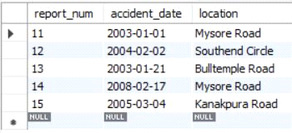

insert into owns values('A01','KA052250');

insert into owns values('A02','KA053408');

insert into owns values('A03','KA095477');

insert into owns values('A04','KA031181');

insert into owns values('A05','KA041702');

select * from owns;

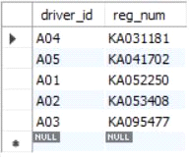

insert into participated values('A01','KA052250',11,10000);

insert into participated values('A02','KA053408',12,50000);

insert into participated values('A03','KA095477',13,25000);

insert into participated values('A04','KA031181',14,3000);

insert into participated values('A05','KA041702',15,5000);

select * from participated;

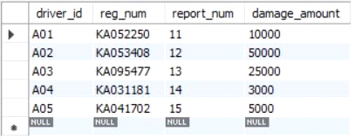

**iii. Demonstrate how you**

**a. Update the damage amount for the car with a specific Regno in the accident with report number 12 to 25000.**

update participated set damage_amount=25000 where report_num=12;

select * from participated;

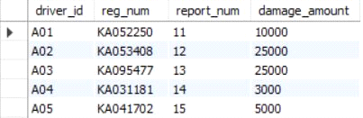

**b. Add a new accident to the database.**

insert into accident values('28','18-01-2018','Muesuem road');

select *from accident;

**iv. Find the total number of people who owned cars that involved in accidents in 2008.**

select count(*) from accident where year(accident_date)=2008;



**v. Find the number of accidents in which cars belonging to a specific model were involved**

select count(*) as no_of_acc from participated where reg_num in(select reg_num from car where model='Lancer');

